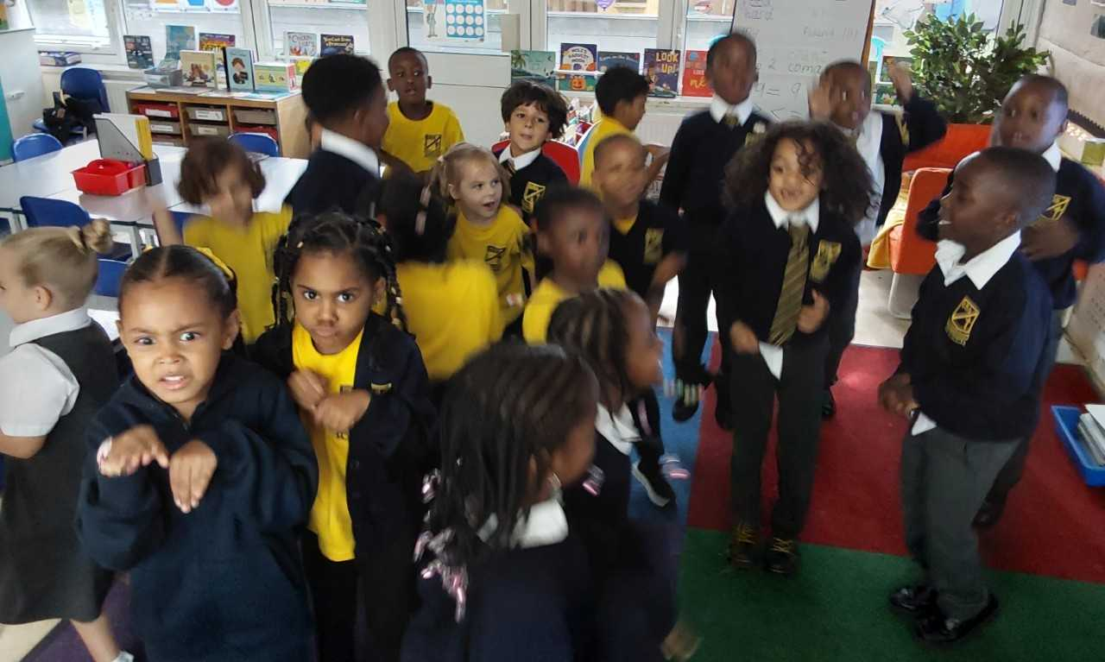
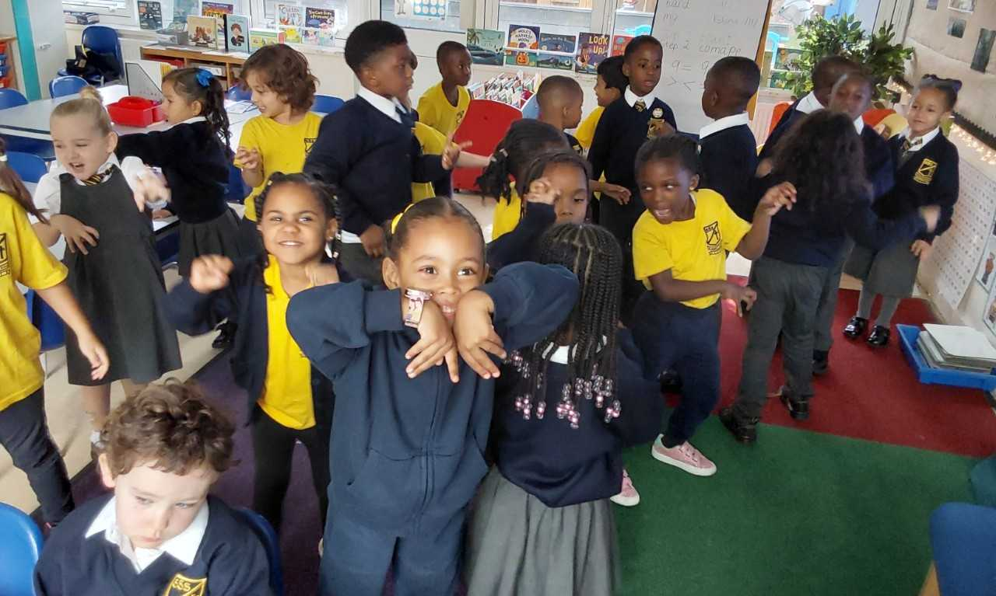
This week (WC 21/09/26), Year 1 have been enjoying the wonderful story Cave Baby by Julia Donaldson. We brought the story to life by acting out the different animals and copying their movements. We also developed our descriptive language by thinking carefully about the characters and using adjectives to describe what they look like and how they behave. The children had lots of fun using actions, expression and their imaginations to explore the story!

